**1. Select one video prompt**This year, we’re giving Local Guides three prompts to choose from. Choose one of the following and keep your response to approximately 60 seconds:   
  
- Tell us about your favorite place and what makes it special.  
- What’s one thing you want everyone to know about your community?  
- Why are you proud to be a Local Guide?    
  
*Please note: Videos longer than one minute may not be viewed.*

**2. Be yourself**We’re interested in learning about you, so be as creative or as low-key as you want while giving us a glimpse into your personality. Don’t worry about adding sound effects, video transitions, or graphics if video production is new to you. You must appear on-camera, speak in English, and answer a prompt, but do so in your own way! 

**3. Wear something comfortable that makes you feel confident**  
You may also want to remove items like hats or sunglasses that can cast a shadow on your face.

**4. Assess your surroundings**An ideal background is clean and pleasant. Lighting is important and natural light works best. Make sure you’re not backlit by a large window or light shining into the camera. Position yourself facing a window or another light source to ensure the lighting on you is bright and casts an even spread across your face.

If you’re filming on location, try to avoid places with loud ambient noises such as rushing water, water fountains, loud subways, or street traffic. Check light and sound levels by taking a few seconds of test footage before you start your application video.

**5. Compose yourself in the center of the frame and leave a little headroom**A good rule to follow is to have the camera positioned at arm’s length. If you’re using a smartphone, tapping where your face is on the screen before recording will ensure that you’re in focus. Make sure your camera is facing you straight-on rather than angled up at you from below.

*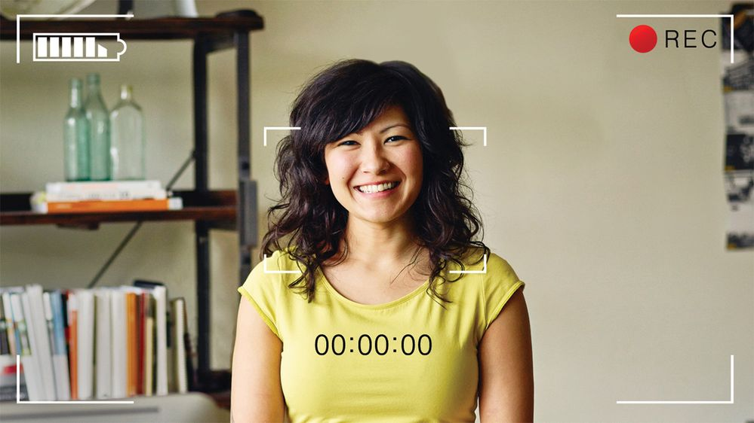Caption: A photo of a young woman smiling at the camera with a video recording graphic overlay. (Getty Images)*

**6. Keep the camera stabilized**  
If you’re using a smartphone to record, consider propping it on a flat surface like a stack of books or a box. You can also use a tripod if you have one. 

**7. Control the audio**Do what you can to make sure your surroundings are quiet. Eliminate noise by shutting windows or doors and turning off noisy electronics. Be mindful that microphones can pick up noises like fans or tapping fingers on a desk. You may want to use a USB or bluetooth microphone if you have one. 

**8. Film in landscape**Make sure your smartphone or camera is positioned horizontally instead of vertically. This maximizes the screen space.

**9. Submit your video carefully**We may never watch your video if the link is submitted incorrectly. Applicants must submit their video as either a [YouTube](https://support.google.com/youtube/answer/157177?co=GENIE.Platform%3DDesktop&hl=en" \t "_blank)or [Google Drive](https://support.google.com/drive/answer/2494822?hl=en&ref_topic=7000947) link. You can submit a listed or unlisted YouTube link or link to a video stored on Google Drive that is accessible to anyone with the link.

If you’re using YouTube, you must submit the link provided once the video is posted. Do not share the link created while the video is in production. The production link cannot be viewed by anyone other than you.

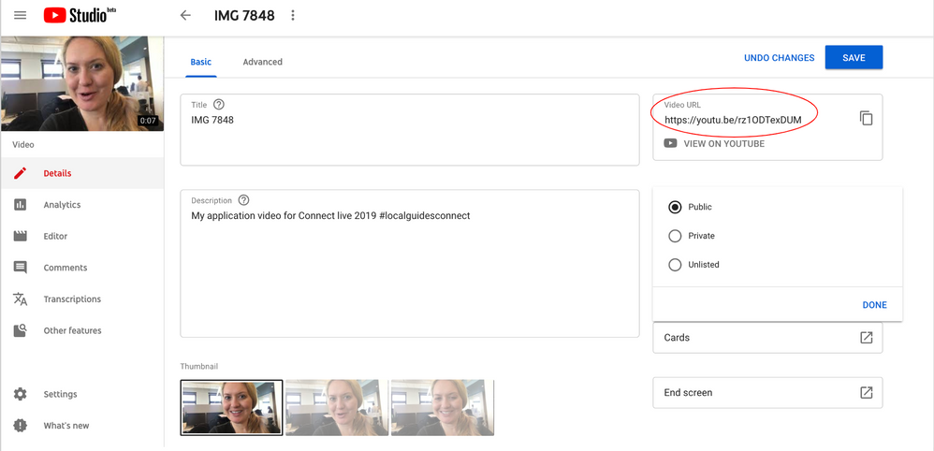*A screenshot the “Basic” edit page on YouTube after a video has been uploaded with a red circle around the Video URL. It shows where you can add a title, description, and change your viewer settings. You can also access the correct video URL to submit from this screen.*

If you’re submitting a video on Google Drive, copy the link generated after you click **Share**in the top right corner. Be sure your share settings are set to **Anyone with the link can view**.

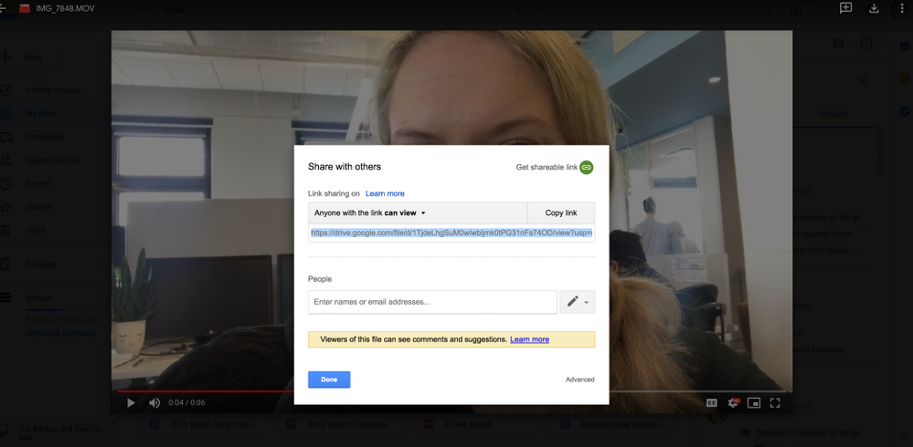*Caption: A screenshot of a video on Google Drive with a pop-up box that appears after you click “Share.” Here, you can change your viewer settings to “Anyone with the link can view.” Paste this link into your Connect Live 2019 application.*

**Remember to submit your video before applications close on April 30, 2019 at 11:59 p.m. UTC. Visit**[**the official Connect Live 2019 application site**](https://maps.google.com/localguides/event/connectlive)**for more information.**